Spiceland
Indiana
Est. 1842

Why should YOU invest your business in Spiceland?

It’s as easy as 1…2…3!!

- Easily marketable
Spiceland is located right off of I-70, exit #123. This easy accessibility makes Spiceland a prime spot for your business.

- Infrastructure already exists
The road is there and is newly paved. We have multiple empty buildings that already have all of the necessities in place. All you need to do is move in! And, the infrastructure that is not prepared is shovel-ready!

- Inexpensive rates
The utility rates in Spiceland are cheaper than any of the surrounding area’s rates. The town council is open to negotiations for tax incentives and other benefits for placing your business here in Spiceland. Spiceland is very business-friendly!

Keep in mind…

Spiceland has a consistent population of 890 people. On any given day, that number increases by at least 600 people. The town sees about 40,000 cars just along I-70. St Rd 3, coming from the South side where I-70 and the annexation starts, sees about 7,200 cars a day. About 6000 cars a day travel through Spiceland. These site numbers increase during race season. Thanks to the annexation, there are multiple plots of commercial land available right off of I-70.

Development Opportunities in Spiceland
Land  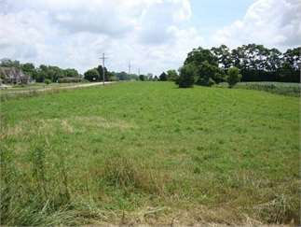  000 E Mercer ~ 2.55 acres ~ $18,500  3 lots perfect for building. South side of Spiceland, Tri High Schools. Close access to Interstate 70, US Hwy 40 and SR 3  Contact: Julia Hoffman Crossroads Real Estate Mgt LL  (765) 521-9464  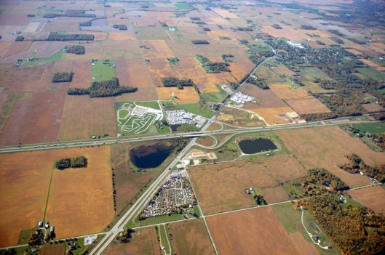  5300 S St Rd 3  Spacious, flat land conveniently located right off of I-70 and right next to a Flying J gas station. This land is also adjacent to the New Castle Motorsports Park  Contact: Pierce, Inc  6293 S St Rd 3  Prime farmland located near Church of the Nazarene right along St Rd 3  Contact: Trent Dishman (765) 987-7305  140 Holwager Dr  Property around Mr. Fuel – auction 11/9  Contact: Halderman Real Estate  crisp@halderman.com  For Rent  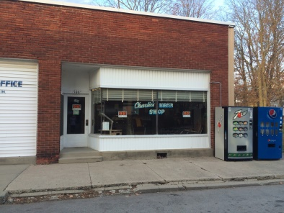  104 E Main St  This building is the perfect place for your next barber shop.  Contact: Jerry Linder (765) 524-3576 | Buildings  6643 S St Rd 3 ~ 0.27 acres ~ $250,000  Built in 1976, this building is excellent opportunity for a new business. Fully functioning restaurant includes all equipment so you can continue operations.  Contact: Lindsay King Crossroads Real Estate Mgt LLC  (765) 521-9464  408 Main St  This building was previously an elementary school so it is fully-equipped with all of your basic business needs. Located right across from the Spiceland Friends Church.  Contact: Jeff Davies, P.O. Box #1192, Madison, Alabama 35758  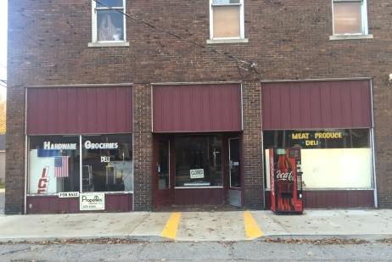  103 W Main St  This multi-use building was previously a local grocery store (Wilson’s Market) in the heart of Spiceland.  Contact: Dick Masters Properties Unlimited, Inc  (765) 524-1653  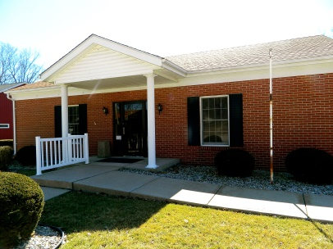  121 E Main St  This building was the previous Bank of Spiceland. It is fully-equipped with necessary utilities and is move—in ready!  Contact: Trent Dishman (765) 987-7305
U.S. Small Business Administration:
10 Steps to Starting a Business
in Spiceland, Indiana

Step #1: Write a Business Plan
This is the roadmap for the success of your business. It generally projects 3-5 years ahead and includes an executive summary, company description, market analysis, organization & management, service or product line, marketing & sales, financial projections, funding request (optional), and an appendix.

Step #2: Get Business Assistance and Training
The town of Spiceland would be happy to assist you with your business needs. The Henry County Economic Development Corporation has many resources for you and your new business.

Step #3: Choose a Business Location
Spiceland has plenty of land and buildings available for your business. Choose the right location for your business based on your brand image, competition, local labor market, future growth, proximity to suppliers, safety, and zoning regulations. Property is zoned into commercial and residential uses so be sure the land is zoned for commercial use.

Step #4: Finance Your Business
Keep an eye out for hidden costs; very few places are business-ready. Remember that the Income State Tax rate is 3.4” and sales tax rate is 7% for Indiana. The minimum wage for Indiana is $7.25. The town council has already been in talks of negotiating tax incentives and other benefits.

Step #5: Determine the Legal Structure
You must decide what form of business entity you’d like to be (sole proprietorship, limited liability, cooperative, corporation, partnership, or S corporation). This determines which Federal income tax return form you have to file.

Step #6: Register a Business Name
Also known as your “Doing Business As” (DBA) name, your business name is the officially registered name of your business entity. You must register this name at the Henry County County Clerk (Debra Walker)’s office or the government of the State of Indiana.

Step #7: Get a Tax Identification Number
It is necessary for your new business to obtain a Tax Identification Number. To obtain a tax ID number, you’ll have to contact the Indiana Department of Revenue at http://www.in.gov/dor/

Step #8: Register for State and Local Taxes
Your new business will have to pay state and local taxes, including income taxes and employment taxes. You can register for these at www.in.gov

Step #9: Obtain Business Licenses and Permits
There are mandatory Federal and State licenses and permits that you will need. Federal permits are required for businesses that are supervised and regulated by a federal agency, such as aviation, firearms, fish & wildlife, commercial fisheries, maritime transportation, mining & drilling, radio & TV broadcasting, and transportation & logistics. Some specific occupational licenses and permits required by states include the selling of alcoholic beverages, health issues, contractor services, day care center, financial services, and transportation. You will also need a Seller’s Permit if you buy or sell wholesale (bulk) or retail (small amounts).

Step #10: Understand Employer Responsibilities
There are a few steps that need to be completed when hiring your first employee. Step one is obtaining an employer identification number (EIN) from the U.S. Internal Revenue Service. This number is often referred to as your Employer Tax ID or as Form SS-4. Next you must set up records for withholding taxes. You must keep records for your employees for at least four years. Prepare financial statements, identify sources of receipts, keep track of deductible expenses, prepare tax returns, etc. Three types of withholding taxes you need for your business are: Federal Income Tax Withholding, Federal Wage and Tax Statement, and State Taxes. Step three is employee eligibility verification. This includes your prospective employees filling out an I09. Step four is to register with Indiana’s New Hire reporting Program. Within 20 days of their hire or rehire date. Step five is to obtain workers compensation insurance coverage through a commercial carrier. Step six is to post required notices informing employees of their rights and employers responsibilities under labor laws. Step seven is to file your taxes. If you pay employees, you are subject to file Income Withholding Tax, Social Security, and Medicare taxes. Lastly, step eight is to get organized and keep yourself informed. Maintain a healthy and fair work environment, provide benefits, and keep your employees informed about company policy.

For more information regarding your new business, visit:
https://www.sba.gov/content/follow-these-steps-starting-business

Spiceland Business Guide:

Who You Can Contact

Zoning and Business Development Questions
Henry County Economic Development Corporation
100 S. Main Street, Suite. 203
New Castle, IN 47362
Phone: (765) 521-7402
http://nchcedc.org/

Utilities / Questions
Spiceland has their own utilities that they can offer your business.
Town Office: Dawn Mogg
Spiceland Water & Electric
130 East Main Street, PO Box 386
Spiceland, Indiana, 47385
Phone: (765) 987-1211
http://spicelandtown.org

Permits
Before opening your business in Spiceland, you need to obtain an improvement permit.
For information regarding this permit, contact:
Planning Commission
Henry County Justice Center: Rachel White
1201 Race Street
New Castle IN 47362
Phone: (765) 529-7408

For more information regarding business in Spiceland
Henry County Justice Center
Debra Walker, County Clerk
1215 Race Street, PO Box B
New Castle, IN 47362
Phone: (765) 529-6401
http://www.henryco.net/

